INSTRUCTION MANUAL FOR PIPETTE SHAKER PS-600T

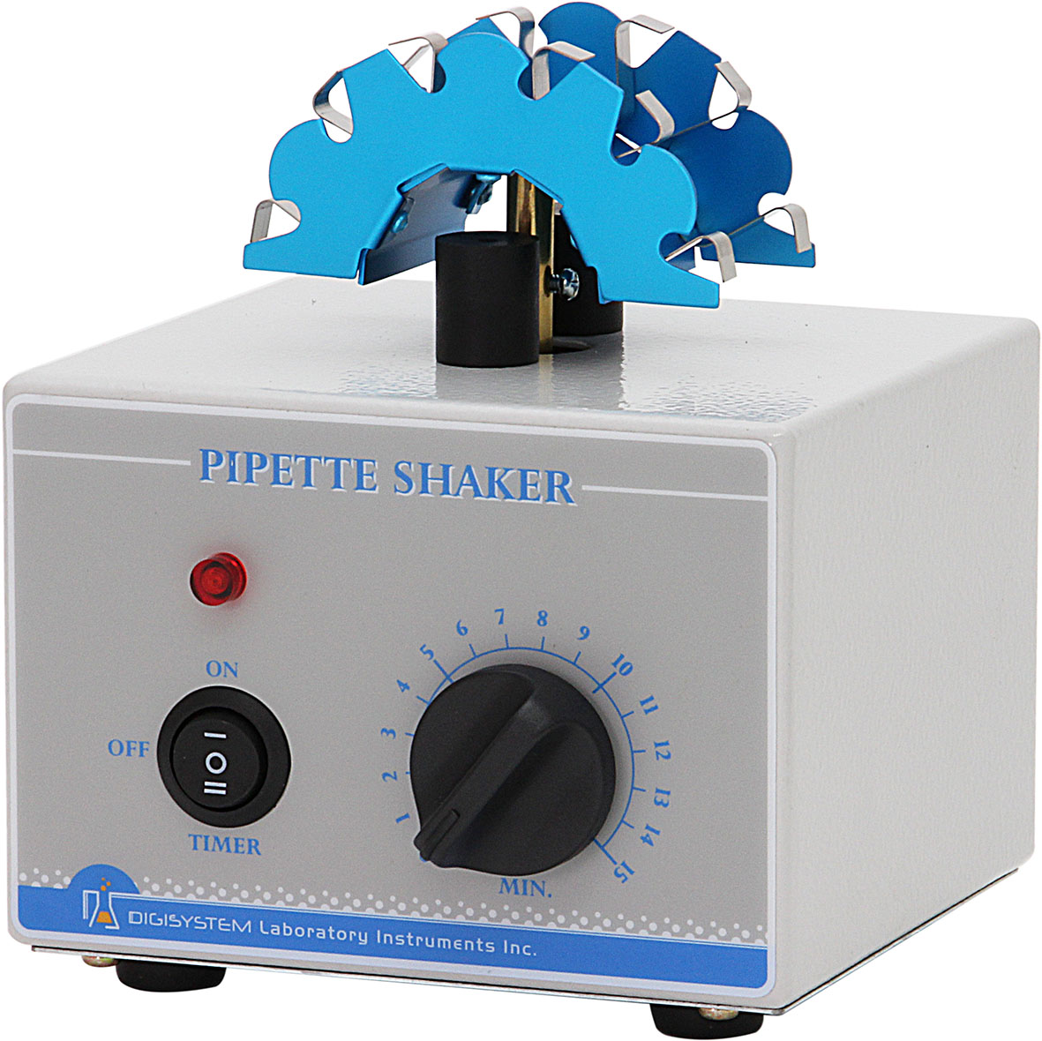
Holder

Power indicator

Switch
Timer

Warnings:
* Do not remove the shaker during operation.
* Place the shaker securely away from the edge of bench to avoid the rotator mixing falling off the bench top.
* Do not disassemble the shaker by yourself. In the event of a malfunction, the shaker should be repaired by a qualified technician. Before repairing, turn off the power.

- Place the pipette shaker on a flat and stable bench top. Plug it into a properly grounded outlet which corresponds with the electrical requirements on the label back on machine.
- Place blood diluting pipettes on the ‘Holder’.
- Select the switch model. You can place the ‘Switch’ at ‘TIMER’, ‘OFF’, or ‘ON’ position. When the ‘Switch’ is at ‘TIMER’ or ‘ON’ position, the ‘Power indicator’ lights.
3.1 If the Timer mode is selected, you can turn the ‘Timer’ to a required scale. There is a bell sound to be heard when the setting time is end.
* How to set the ‘Timer’ correctly?
Turn the ‘Timer’ over the required scale, then return the time calibration as a required scale. (For instance, you need 5 minutes for rotation, but you need to wind to 7 or 8 minute scale at first, then return back to 5 minute scale.)
3.2 If the ‘ON’ mode is selected, the rotator will rotate continuously.
3.3 If the ‘OFF’ mode is selected, the power will be cut off.

Maintenance and care:
Keep the machine clean all the time, so no routine maintenance is required. Cleaning can be done with a damp cloth. Avoid the use of solvents as they may damage the machine housing.

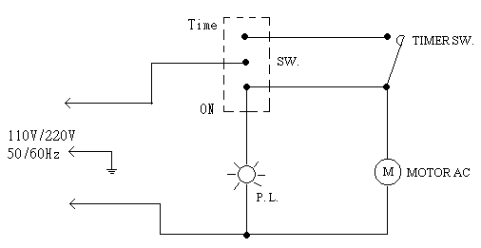
Circuit Diagram

Troubleshooting Guide
Caution: Always disconnect the power cord before troubleshooting.
Trouble | Cause | Remedy
Instrument inoperative. | Power cord not connected to outlet. | Plug in the power cord.
Instrument inoperative. | Dead power output. | Change to different output.
Holder doesn’t shake. | Power is not on. | Place the switch at ‘Timer’ or ‘ON’ position.
Holder doesn’t shake. | Belt is broken | Contact your distributor for repair.
Holder doesn’t shake. | Motor is broken. | Contact your distributor for repair.
Power indicator can not light up. | The power indicator is broken. | Contact your distributor for repair.
Timer is not accurate | Timer is not set by the correct procedures. | Read the operation manual and set it again.
Timer is not accurate | Timer is broken. | Contact your distributor for repair.

